**LAB - 1**

**Document store NoSQL: MongoDB**

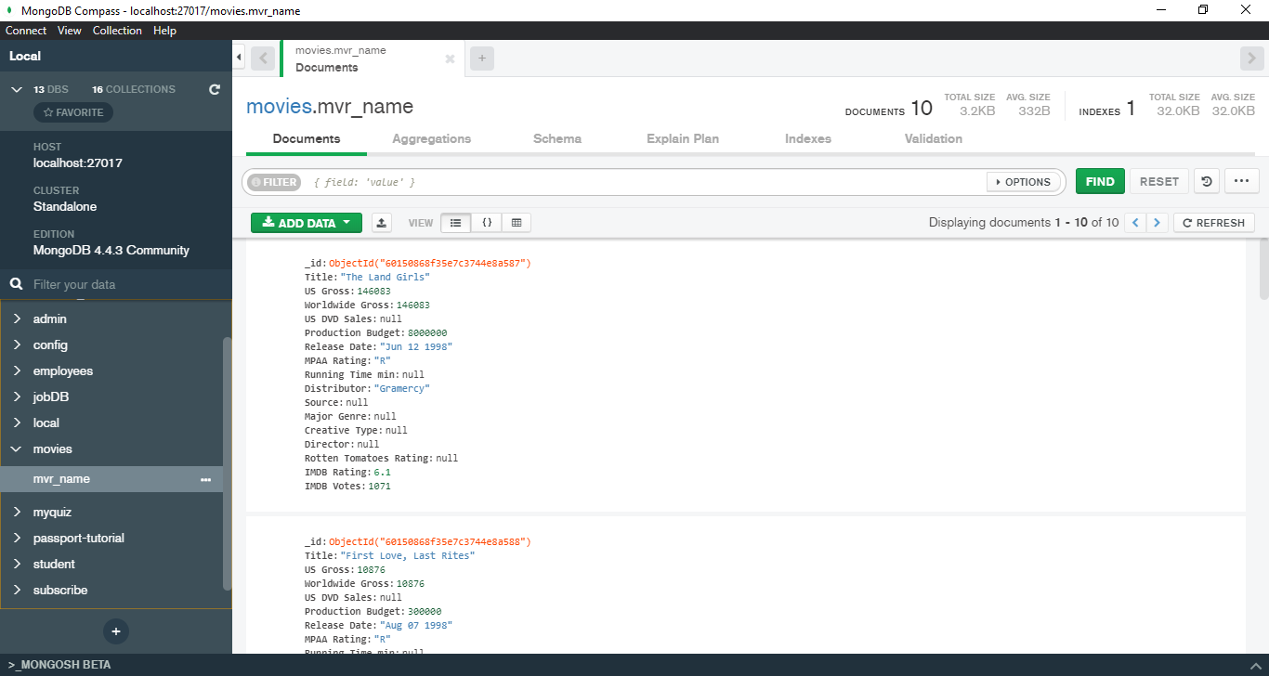

1. Create a database called ‘movies’ and *write* a MongoDB query to select database as ‘movies’.

Code:

|  |
| --- |
| use movies |

Output:

|  |
| --- |
| switched to db movies |

1. Write a MongoDB query to display databases.

Code :

|  |
| --- |
| show dbs |

Output :

|  |
| --- |
| admin 0.000GB config 0.000GB local 0.000GB movies 0.000GB |

1. Create a collection called ‘mvr_name’.(use capping and not capping)

Code(crapping):

|  |
| --- |
| db.createCollection("mvr_name", { capped : true } ) |

Output:

|  |
| --- |
| {  "ok" : 0,  "errmsg" : "specify size:<n> when capped is true",  "code" : 14832,  "codeName" : "Location14832" } |

Code(Not Crapping):

|  |
| --- |
| db.createCollection("mvr_name", { capped : false } ) |

Output:

|  |
| --- |
| { "ok" : 1 } |

1. Add 10 movies details to the collection named”mvr_name”. Each document consists of following properties as Reviewer_name, movie_name, genre (Action, Crime, Horror, Comedy, Animation) as array, director, rating (out of 10), timestamp ( date and year release), reviewer_occupation.

Code:

|  |
| --- |
| db.mvr_name.insert([{Reviewer_name:"Blue sattai",movie_name:"bigil",genre:["Action","comedy"],Director:"atlee",Rating:7,timestamp:new Date("2019-11-27"),Reviewer_occupation:"youtuber"},{Reviewer_name:"Blue sattai",movie_name:"kappan",genre:["Action","comedy"],Director:"K.V.Anand",Rating:6,timestamp:new Date("2019-08-14"),Reviewer_occupation:"youtuber"},{Reviewer_name:"Blue sattai",movie_name:"Ner Konda paarvai",genre:["Action"],Director:"H.Vinoth",Rating:7,timestamp:new Date("2019-09-09"),Reviewer_occupation:"youtuber"},{Reviewer_name:"Blue sattai",movie_name:"IT-2",genre:["Horror"],Director:"Andres Muschietti",Rating:8,timestamp:new Date("2019-04-07"),Reviewer_occupation:"youtuber"},{Reviewer_name:"Blue sattai",movie_name:"Joker",genre:["Crime"],Director:"Todd phillips",Rating:9,timestamp:new Date("2019-09-08"),Reviewer_occupation:"youtuber"},{Reviewer_name:"Blue sattai",movie_name:"Your Name",genre:["Animation"],Director:"Makoto Shinkai",Rating:9,timestamp:new Date("2019-11-27"),Reviewer_occupation:"youtuber"},{Reviewer_name:"Blue sattai",movie_name:"Avengers endgame",genre:["Action"],Director:"Russo brothers",Rating:9,timestamp:new Date("2019-06-29"),Reviewer_occupation:"youtuber"},{Reviewer_name:"Blue sattai",movie_name:"robo",genre:["Action","adventure"],Director:"shankar",Rating:8,timestamp:new Date("2010-09-17"),Reviewer_occupation:"youtuber"},{Reviewer_name:"Blue sattai",movie_name:"robo 2.0",genre:["Action","adventure"],Director:"shankar",Rating:6,timestamp:new Date("2018-10-16"),Reviewer_occupation:"youtuber"},{Reviewer_name:"Blue sattai",movie_name:"kaidhi",genre:["Action"],Director:"lokesh",Rating:8,timestamp:new Date("2019-10-27"),Reviewer_occupation:"youtuber"}]) |

Output:

|  |
| --- |
| BulkWriteResult({  "writeErrors" : [ ],  "writeConcernErrors" : [ ],  "nInserted" : 10,  "nUpserted" : 0,  "nMatched" : 0,  "nModified" : 0,  "nRemoved" : 0,  "upserted" : [ ] }) |

1. Write a MongoDB query to display single document in a database and all the documents in a database. And also Use *pretty()* to display the results.

Code 1:

|  |
| --- |
| db.mvr;_name.find() |

Output:

|  |
| --- |
| { "_id" : ObjectId("5defd3ffe24626f63a775490"), "Reviewer_name" : "Blue sattai", "movie_name" : "bigil", "genre" : [ "Action", "comedy" ], "Director" : "atlee", "Rating" : 7, "timestamp" : ISODate("2019-11-27T00:00:00Z"), "Reviewer_occupation" : "youtuber" } { "_id" : ObjectId("5defd3ffe24626f63a775491"), "Reviewer_name" : "Blue sattai", "movie_name" : "kappan", "genre" : [ "Action", "comedy" ], "Director" : "K.V.Anand", "Rating" : 6, "timestamp" : ISODate("2019-08-14T00:00:00Z"), "Reviewer_occupation" : "youtuber" } { "_id" : ObjectId("5defd3ffe24626f63a775492"), "Reviewer_name" : "Blue sattai", "movie_name" : "Ner Konda paarvai", "genre" : [ "Action" ], "Director" : "H.Vinod", "Rating" : 7, "timestamp" : ISODate("2019-09-09T00:00:00Z"), "Reviewer_occupation" : "youtuber" } { "_id" : ObjectId("5defd3ffe24626f63a775493"), "Reviewer_name" : "Blue sattai", "movie_name" : "IT-2", "genre" : [ "Horror" ], "Director" : "Andres Muschietti", "Rating" : 8, "timestamp" : ISODate("2019-04-07T00:00:00Z"), "Reviewer_occupation" : "youtuber" } { "_id" : ObjectId("5defd3ffe24626f63a775494"), "Reviewer_name" : "Blue sattai", "movie_name" : "Joker", "genre" : [ "Crime" ], "Director" : "Todd phillips", "Rating" : 9, "timestamp" : ISODate("2019-09-08T00:00:00Z"), "Reviewer_occupation" : "youtuber" } { "_id" : ObjectId("5defd3ffe24626f63a775495"), "Reviewer_name" : "Blue sattai", "movie_name" : "Your Name", "genre" : [ "Animation" ], "Director" : "Makoto Shinkai", "Rating" : 9, "timestamp" : ISODate("2019-11-27T00:00:00Z"), "Reviewer_occupation" : "youtuber" } { "_id" : ObjectId("5defd3ffe24626f63a775496"), "Reviewer_name" : "Blue sattai", "movie_name" : "Avengers endgame", "genre" : [ "Action" ], "Director" : "Russo brothers", "Rating" : 9, "timestamp" : ISODate("2019-06-29T00:00:00Z"), "Reviewer_occupation" : "youtuber" } { "_id" : ObjectId("5defd3ffe24626f63a775497"), "Reviewer_name" : "Blue sattai", "movie_name" : "robo", "genre" : [ "Action", "adventure" ], "Director" : "shankar", "Rating" : 8, "timestamp" : ISODate("2010-09-17T00:00:00Z"), "Reviewer_occupation" : "youtuber" } { "_id" : ObjectId("5defd3ffe24626f63a775498"), "Reviewer_name" : "Blue sattai", "movie_name" : "robo 2.0", "genre" : [ "Action", "adventure" ], "Director" : "shankar", "Rating" : 6, "timestamp" : ISODate("2018-10-16T00:00:00Z"), "Reviewer_occupation" : "youtuber" } { "_id" : ObjectId("5defd3ffe24626f63a775499"), "Reviewer_name" : "Blue sattai", "movie_name" : "kaidhi", "genre" : [ "Action" ], "Director" : "lokesh", "Rating" : 8, "timestamp" : ISODate("2019-10-27T00:00:00Z"), "Reviewer_occupation" : "youtuber" } |

Code 2(using pretty) :

|  |
| --- |
| db.mvr_name.find().pretty() |

Output:

|  |
| --- |
| {  "_id" : ObjectId("5defd3ffe24626f63a775490"),  "Reviewer_name" : "Blue sattai",  "movie_name" : "bigil",  "genre" : [  "Action",  "comedy"  ],  "Director" : "atlee",  "Rating" : 7,  "timestamp" : ISODate("2019-11-27T00:00:00Z"),  "Reviewer_occupation" : "youtuber" } {  "_id" : ObjectId("5defd3ffe24626f63a775491"),  "Reviewer_name" : "Blue sattai",  "movie_name" : "kappan",  "genre" : [  "Action",  "comedy"  ],  "Director" : "K.V.Anand",  "Rating" : 6,  "timestamp" : ISODate("2019-08-14T00:00:00Z"),  "Reviewer_occupation" : "youtuber" } {  "_id" : ObjectId("5defd3ffe24626f63a775492"),  "Reviewer_name" : "Blue sattai",  "movie_name" : "Nerkonda parvai",  "genre" : [  "Action"  ],  "Director" : "H.Vinod",  "Rating" : 7,  "timestamp" : ISODate("2019-09-09T00:00:00Z"),  "Reviewer_occupation" : "youtuber" } {  "_id" : ObjectId("5defd3ffe24626f63a775493"),  "Reviewer_name" : "Blue sattai",  "movie_name" : "IT-2",  "genre" : [  "Horrer"  ],  "Director" : "Andres Muschietti",  "Rating" : 8,  "timestamp" : ISODate("2019-04-07T00:00:00Z"),  "Reviewer_occupation" : "youtuber" } {  "_id" : ObjectId("5defd3ffe24626f63a775494"),  "Reviewer_name" : "Blue sattai",  "movie_name" : "Joker",  "genre" : [  "Crime"  ],  "Director" : "Todd phillips",  "Rating" : 9,  "timestamp" : ISODate("2019-09-08T00:00:00Z"),  "Reviewer_occupation" : "youtuber" } {  "_id" : ObjectId("5defd3ffe24626f63a775495"),  "Reviewer_name" : "Blue sattai",  "movie_name" : "Your Name",  "genre" : [  "Animation"  ],  "Director" : "Makoto Shinkai",  "Rating" : 9,  "timestamp" : ISODate("2019-11-27T00:00:00Z"),  "Reviewer_occupation" : "youtuber" } {  "_id" : ObjectId("5defd3ffe24626f63a775496"),  "Reviewer_name" : "Blue sattai",  "movie_name" : "Avengers endgame",  "genre" : [  "Action"  ],  "Director" : "Russo brothers",  "Rating" : 9,  "timestamp" : ISODate("2019-06-29T00:00:00Z"),  "Reviewer_occupation" : "youtuber" } {  "_id" : ObjectId("5defd3ffe24626f63a775497"),  "Reviewer_name" : "Blue sattai",  "movie_name" : "robo",  "genre" : [  "Action",  "adventure"  ],  "Director" : "shankar",  "Rating" : 8,  "timestamp" : ISODate("2010-09-17T00:00:00Z"),  "Reviewer_occupation" : "youtuber" } {  "_id" : ObjectId("5defd3ffe24626f63a775498"),  "Reviewer_name" : "Blue sattai",  "movie_name" : "robo 2.0",  "genre" : [  "Action",  "adventure"  ],  "Director" : "shankar",  "Rating" : 6,  "timestamp" : ISODate("2018-10-16T00:00:00Z"),  "Reviewer_occupation" : "youtuber" } {  "_id" : ObjectId("5defd3ffe24626f63a775499"),  "Reviewer_name" : "Blue sattai",  "movie_name" : "kaidhi",  "genre" : [  "Action"  ],  "Director" : "lokesh",  "Rating" : 8,  "timestamp" : ISODate("2019-10-27T00:00:00Z"),  "Reviewer_occupation" : "youtuber" } |

1. find the highest and lowest rating movie and update the movie rating as maximum- minimum and minimum to Maximum.

Code:

|  |
| --- |
| db.mvr_name.aggregate([ { "$group": { "_id": null, "MaximumValue":{ "$max": "$Rating" }, "MinimumValue": { "$min": "$Rating" }}} ]); |

Output:

|  |
| --- |
| { "_id" : null, "MaximumValue" : 9, "MinimumValue" : 6 } |

1. MongoDB Querying:

* Find the total number of rating movies rated by user belonging to specific occupation.

Code:

|  |
| --- |
| db.mvr_name.aggregate([{$group : {_id : "$Reviewer_occupation", sum : {$sum : 1}}}]) |

Output:

|  |
| --- |
| { "_id" : "youtuber", "sum" : 20 } |

* Find the average rating by reviewer and movie.

Code:

|  |
| --- |
| db.mvr_name.aggregate([{ "$group": {"_id": null, "average rating":{"$avg": "$Rating" }}} ]); |

Output:

|  |
| --- |
| { "_id" : null, "average rating" : 7.7 } |

* Find the movie name filmed between 2015 and 2017 and also find the 3rd highest rated movie. [Hint: use sort, limit, skip]

Code for movie filmed between 2015 and 2017:

|  |
| --- |
| db.mvr_name.find({"timestamp":{$gte:new ISODate("2015-01-01T00:00:00Z"),$lte:new ISODate("2017-12-30T00:00:00Z")}}) |

Output:

|  |
| --- |
| { "_id" : ObjectId("5defd3ffe24626f63a775498"), "Reviewer_name" : "Blue sattai", "movie_name" : "robo 2.0", "genre" : [ "Action", "adventure" ], "Director" : "shankar", "Rating" : 6, "timestamp" : ISODate("2018-10-16T00:00:00Z"), "Reviewer_occupation" : "youtuber" } |

Code for 3rd highest:

db.mvr_name.find({},{"movie_name":1,_id:0}).sort({"Rating":-1}).limit(1).skip(2)

Output:

{ "movie_name" : "Avengers endgame" }